**Case Study-4**

**Azure Databricks Case Study**

Name: **Harish E.R**

**Q.** **create a ETL pipeline of ingestion & transform and load queries on any data set and initiate the pipeline from workflow using notebook.**

1. **Notebook for Ingestion (Extract)**

This notebook will load the raw data into the Databricks environment, either from a file or a table.

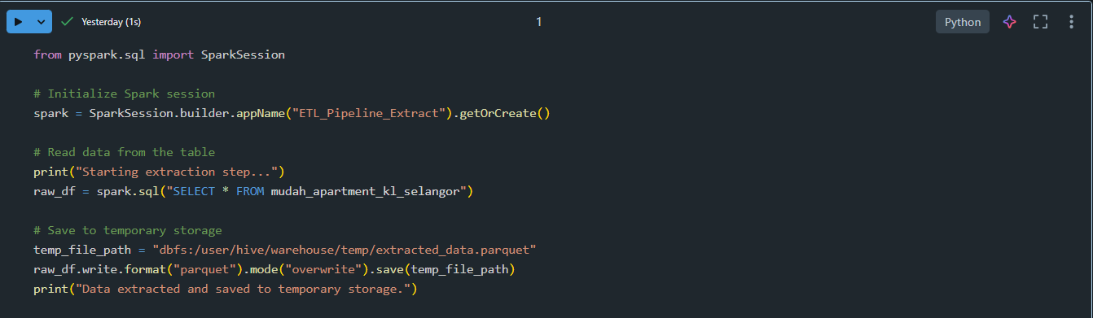

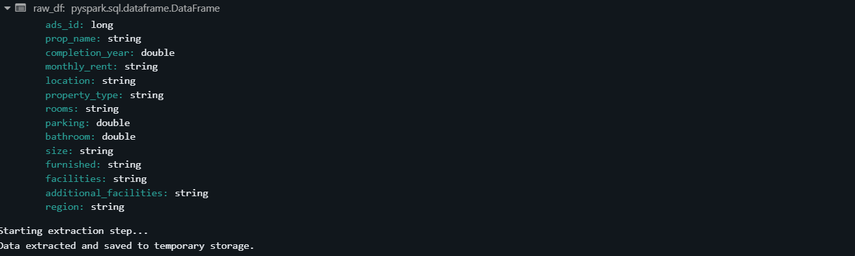

1. **Notebook for Transformation**

This notebook will read the extracted data, apply transformations, and prepare it for loading.

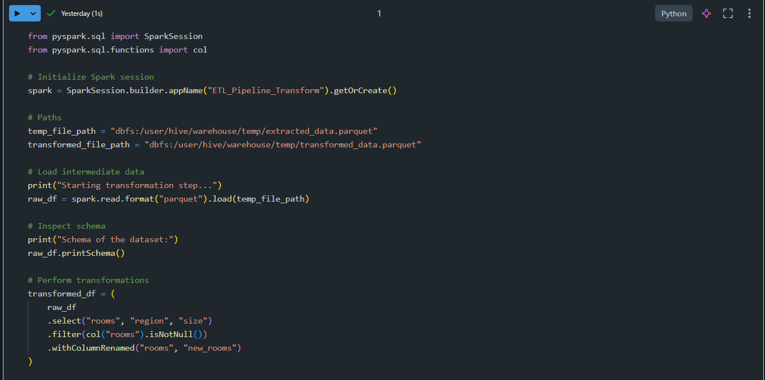

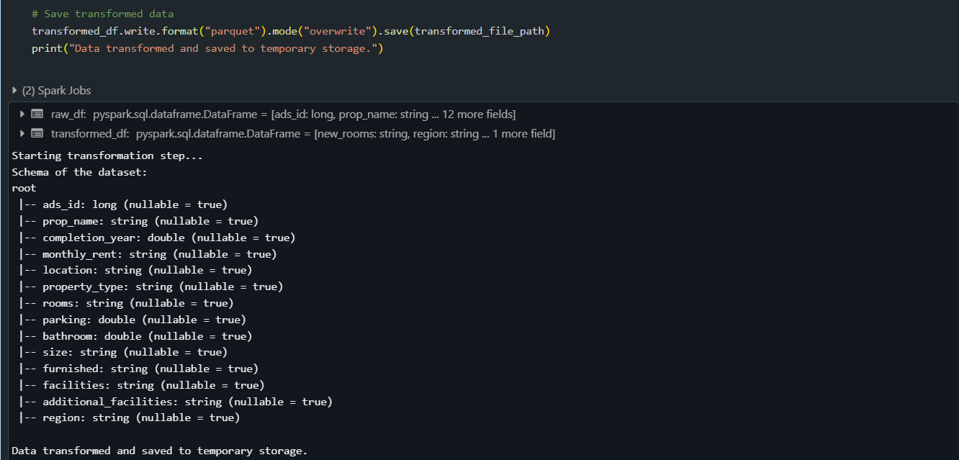

1. **Notebook for Loading**

This notebook will load the transformed data into the final destination, such as a Delta table or another storage format.

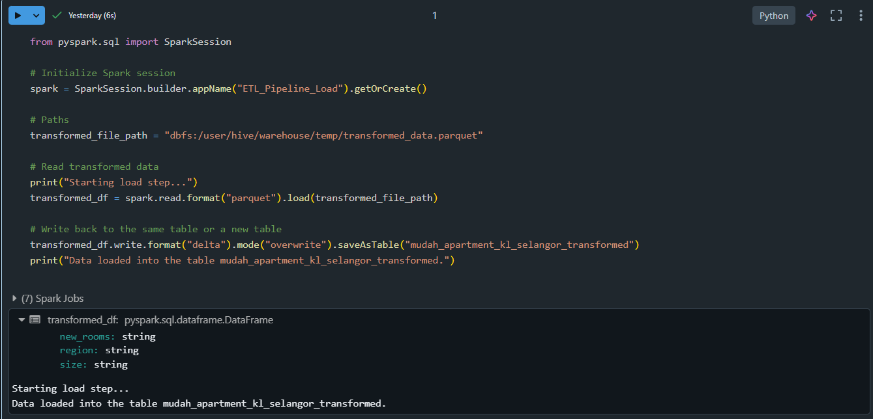

1. **Create a Databricks Workflow**

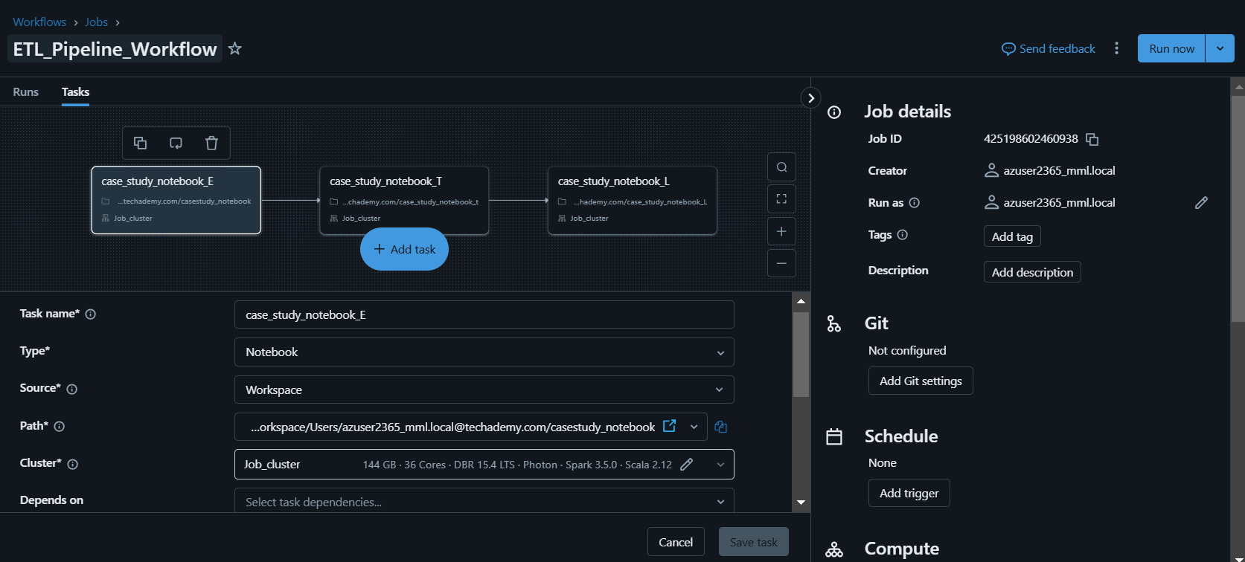

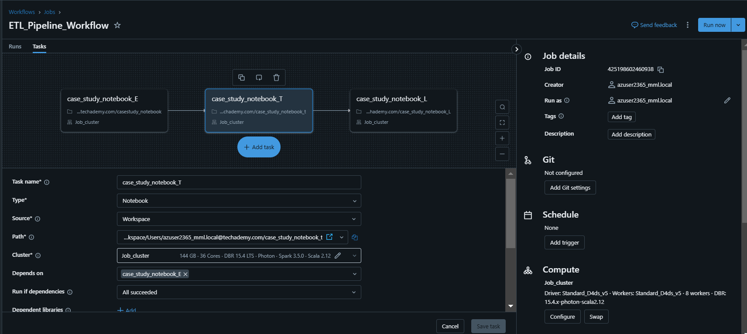

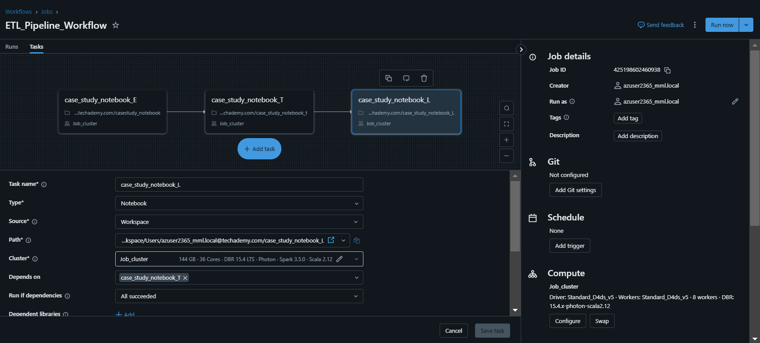

1. **Run the Workflow**

